Apache Kafka
—----------------------------------------------------------------------------------------------------------------------------
Kafka is an open-source distributed event streaming platform. It is initially developed by LinkedIn and later on it is managed by Apache.
Kafka Cluster: Kafka works as a cluster which contains one or more brokers.
Kafka Broker: The Producers produce the message (it can be any event or simple text message) and send it to the Kafka cluster.
Consumer: The consumer consumes those messages from the Kafka broker.
Topic: We create a topic in the Kafka cluster so that the consumer is able to subscribe to that particular topic.
Zookeeper: Service zookeeper, which basically manages the states of all the brokers.
zookeeper also manages the configurations of the topics, producers and consumers.

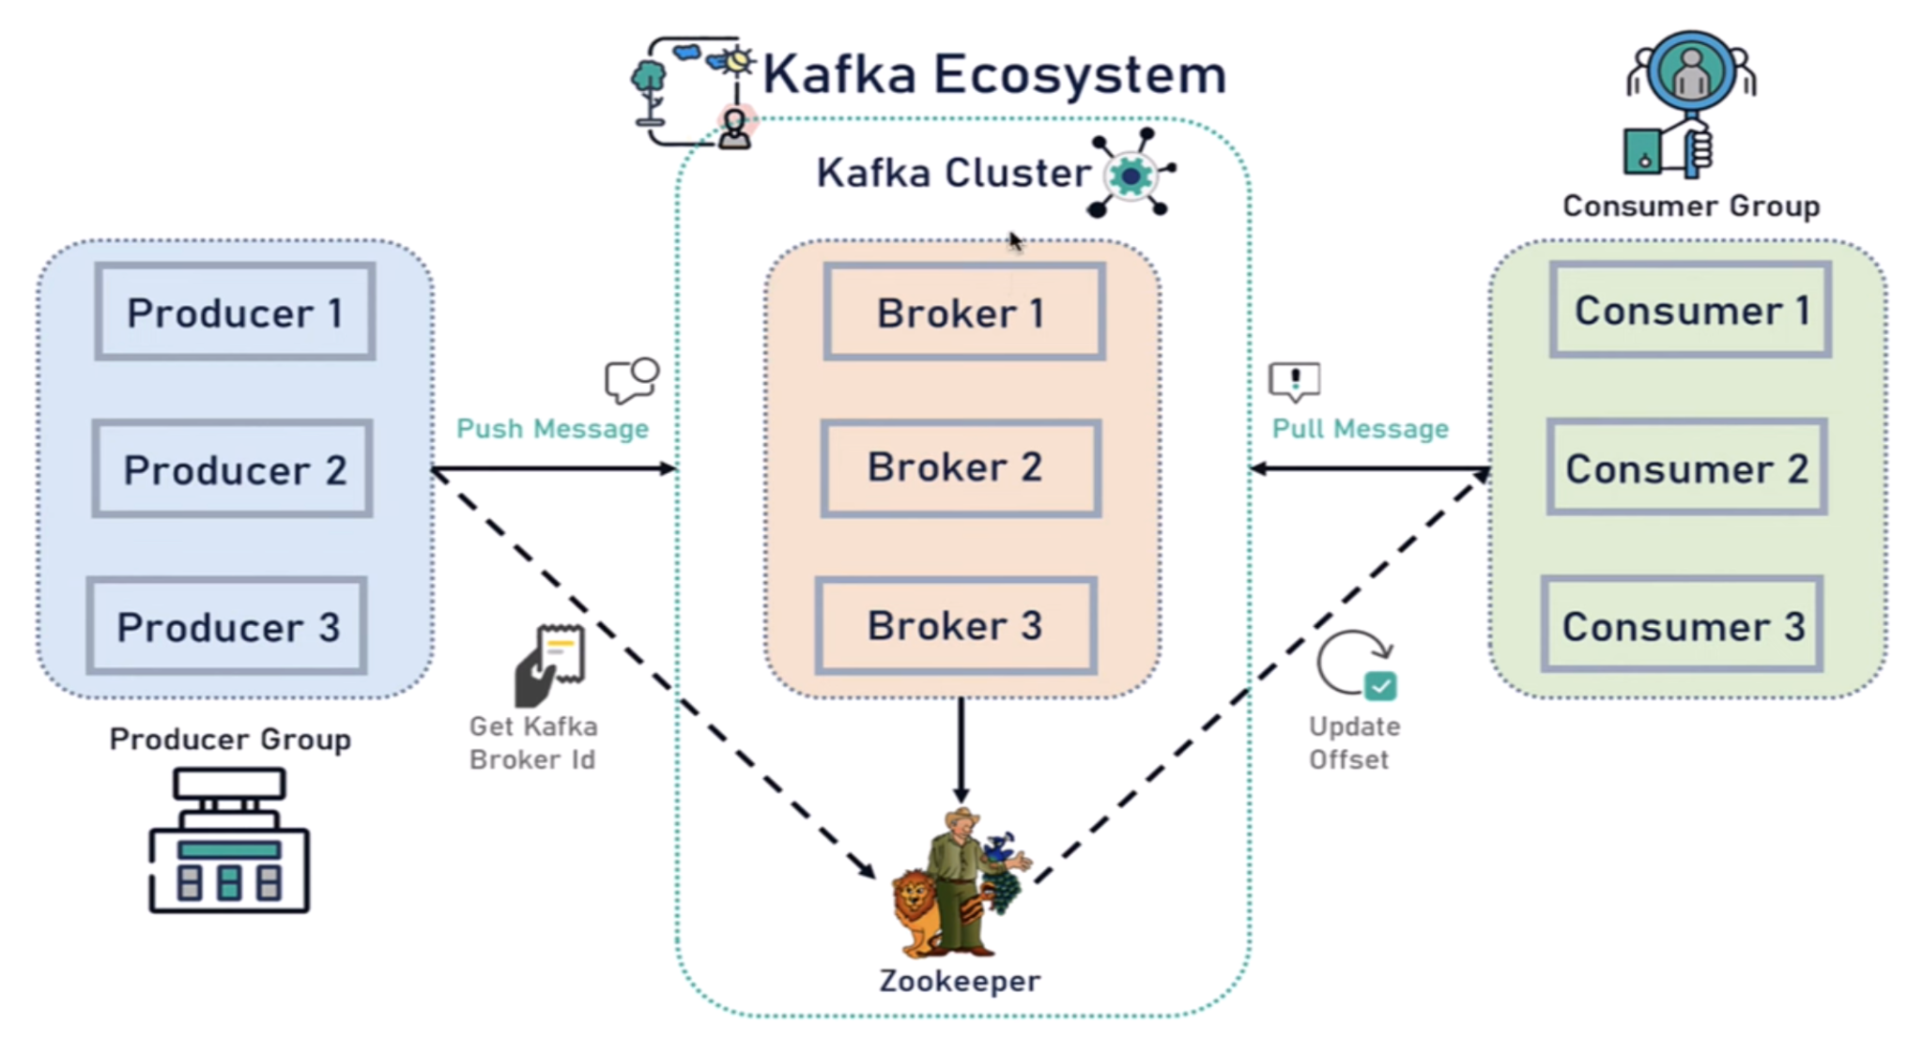
Its recommended, Kafka cluster has a minimum of 3 brokers.
Kafka topics are divided into a number of partitions.
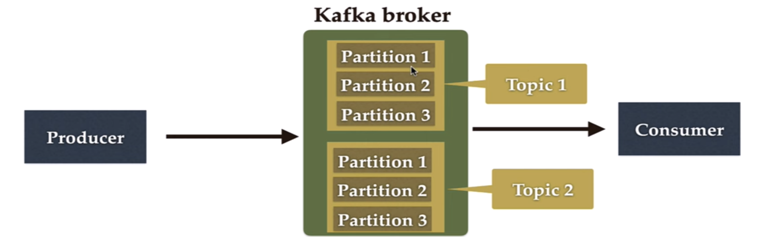
Consumer Groups: A consumer group contains one or more consumers working together to process the messages

Event Driven Architecture
—------------------------------------------------------------------------------------------------------------------------
Event Driven Architecture(EDA) is a software design pattern in which decoupled applications can asynchronous publish and subscribe to events via a n event broker/message broker
In Event Driven architecture, applications communicate with each other by sending andr/or receiving events or messages.
Event Driven Architecture is often referred to as “asynchronous” Communication.
Event Driven Architecture is loosely coupled.
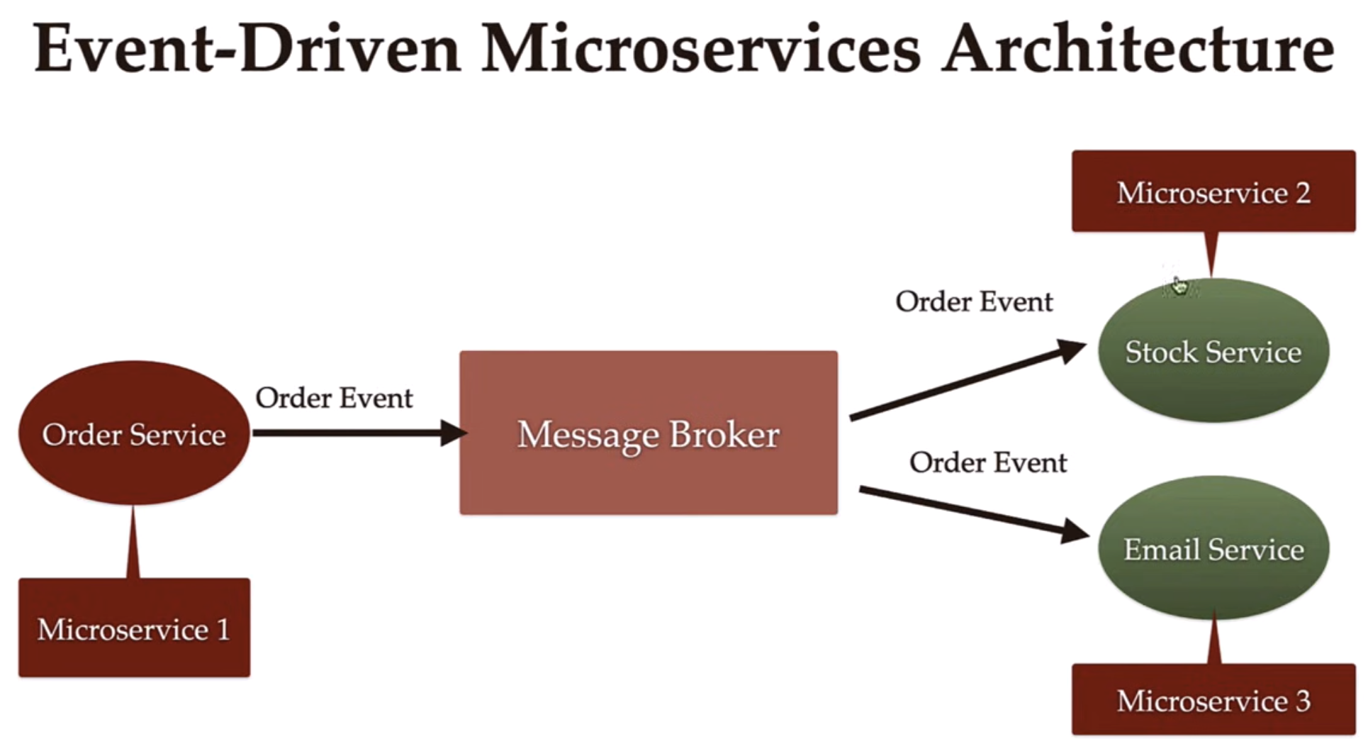
EDA improves Flexibility and Maintainability.
For eg. here Order Service is only responsible for collecting order, creating order event and placing that event into message broker
Similarly stock service is responsible for updating the stock in the DataBase
And Email Service is responsible for sending the email to the customer.
All micro services are independent to each other they just communicate via a middle ware Message Broker

